Create SSIS package for below functionalities.  
Copy:---Copy file from source path to achieve path  
Move:---move file from source path to achieve path(Deleted file in source path)  
Delete: Delete file from source path

Copy:

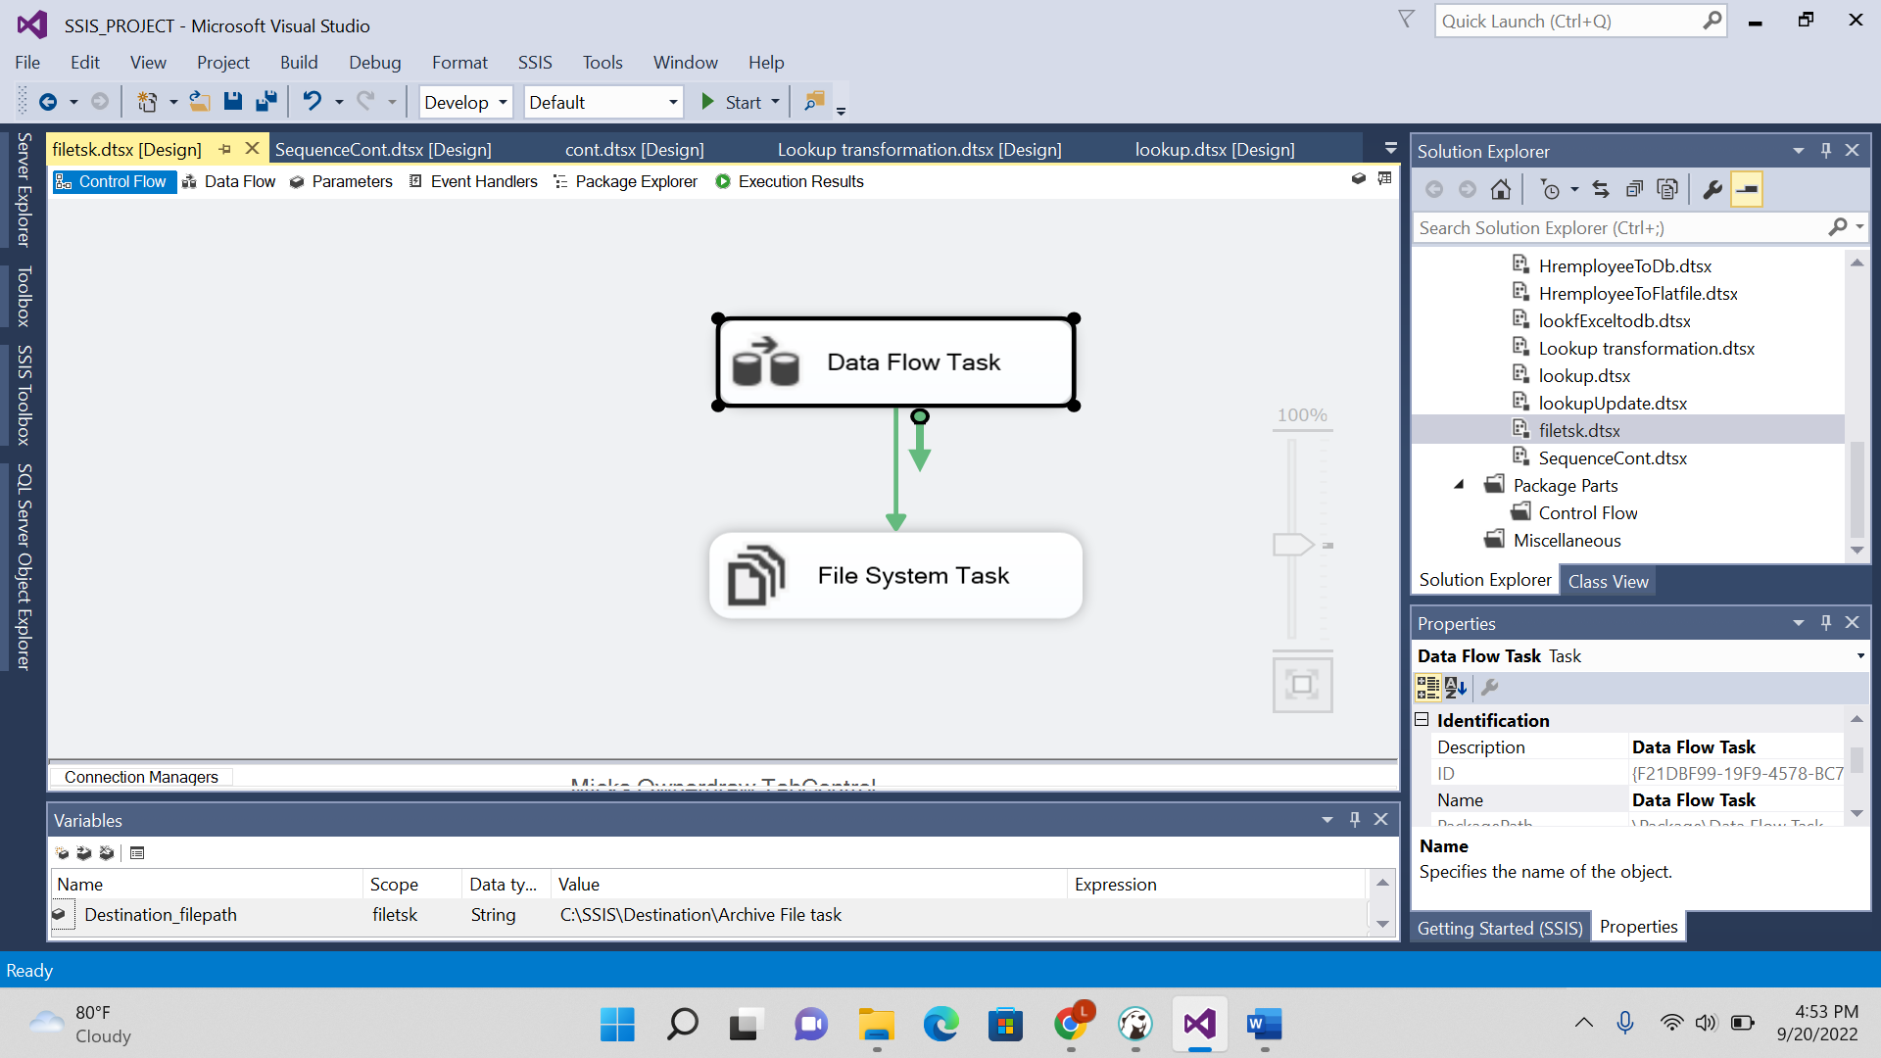

Move:

Delete:

